Database Sharding
Any application or website that sees significant growth will eventually need to scale in order to accommodate increases in traffic. For data-driven applications and websites, it’s critical that scaling is done in a way that ensures the security and integrity of their data. It can be difficult to predict how popular a website or application will become or how long it will maintain that popularity, which is why some organizations choose a database architecture that allows them to scale their databases dynamically.

What is Sharding?
Sharding is a database architecture pattern related to horizontal partitioning — the practice of separating one table’s rows into multiple different tables, known as partitions. Each partition has the same schema and columns, but also entirely different rows. Likewise, the data held in each is unique and independent of the data held in other partitions.
It can be helpful to think of horizontal partitioning in terms of how it relates to vertical partitioning. In a vertically-partitioned table, entire columns are separated out and put into new, distinct tables. The data held within one vertical partition is independent from the data in all the others, and each holds both distinct rows and columns. The following diagram illustrates how a table could be partitioned both horizontally and vertically:
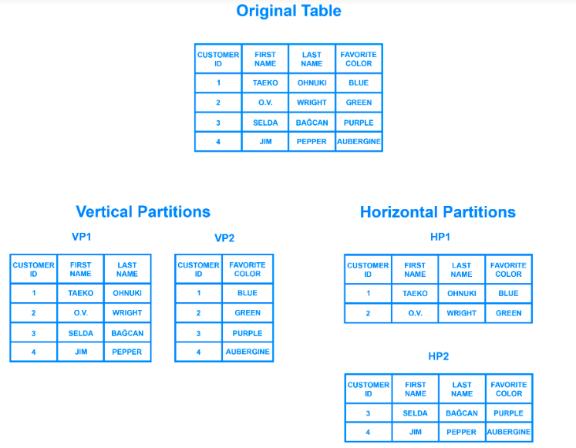
Sharding involves breaking up one’s data into two or more smaller chunks, called logical shards. The logical shards are then distributed across separate database nodes, referred to as physical shards, which can hold multiple logical shards. Despite this, the data held within all the shards collectively represent an entire logical dataset.

Key Based Sharding
Key based sharding, also known as hash based sharding, involves using a value taken from newly written data — such as a customer’s ID number, a client application’s IP address, a ZIP code, etc. — and plugging it into a hash function to determine which shard the data should go to. A hash function is a function that takes as input a piece of data (for example, a customer email) and outputs a discrete value, known as a hash value. In the case of sharding, the hash value is a shard ID used to determine which shard the incoming data will be stored on. Altogether, the process looks like this:
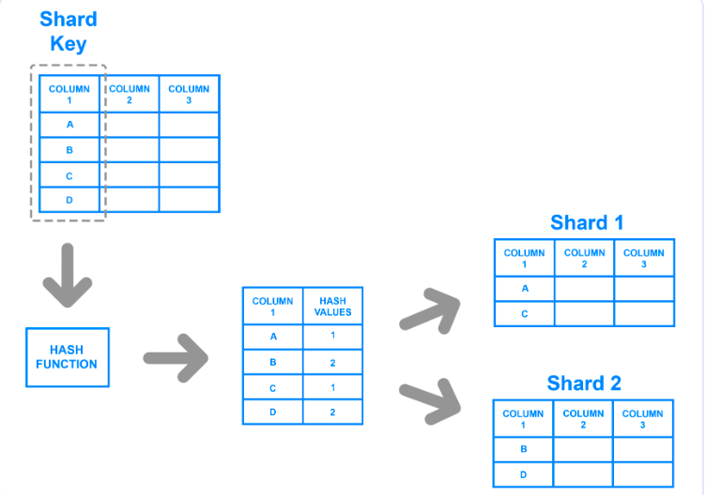

Range Based Sharding
Range based sharding involves sharding data based on ranges of a given value. To illustrate, let’s say you have a database that stores information about all the products within a retailer’s catalog. You could create a few different shards and divvy up each products’ information based on which price range they fall into, like this:
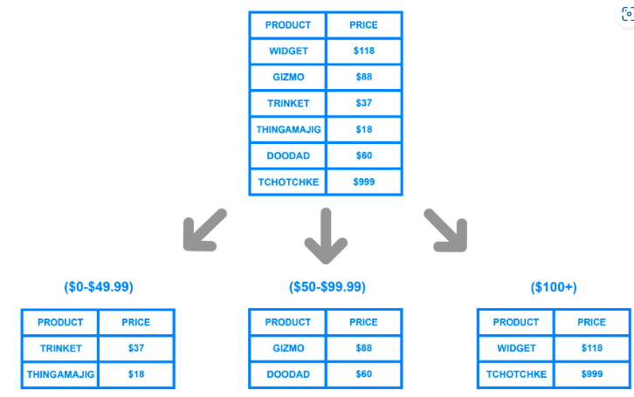

Directory Based Sharding
To implement directory based sharding, one must create and maintain a lookup table that uses a shard key to keep track of which shard holds which data. A lookup table is a table that holds a static set of information about where specific data can be found. The following diagram shows a simplistic example of directory based sharding:
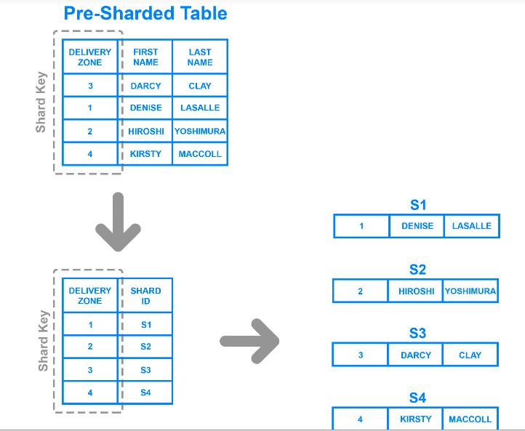

MySQL Data Sharding: What Are the Pros & Cons?
The follow are pros for MySQL data sharding:
- Sharding reduces throughput considerably when applied properly.
- Sharding can help reduce your storage footprint.
- Sharding allows node balancing — and if shards are optimally placed, users can have access to relevant data and the ability to handle complex queries.
There are some instances where MySQL data sharding is not the best approach, and only presents further challenges:
- Establishing an analytics interface over a sharded database is very difficult due to limitations on JOINS and Aggregations.
- Sharded databases in MySQL are mostly ACID (Atomicity, Consistency, Isolation and Durability) compliant.
- MySQL does not provide automated sharding — sharding is normally implemented at the application layer. That means development teams are responsible for the entirety of sharding and maintenance. As such, MySQL is not suited in situations where sharding is required.

